Medieval Alchemy
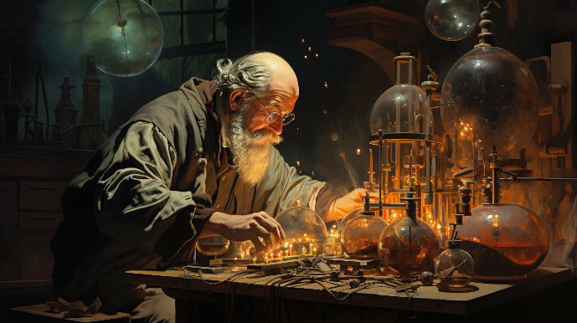
In a mystical kingdom, an alchemist is on a quest to craft five legendary potions, each requiring specific magical ingredients and crystal energy. This journey is challenging, as substances and energy are limited and must be used precisely.

Potions to Craft
You will have to memorize all crafted potion names. The alchemist aims to craft all of the following potions:
Potion | Energy Level
Brew of Immortality | 110
Essence of Resilience | 100
Draught of Wisdom | 90
Potion of Agility | 80
Elixir of Strength | 70

Input Data
- On the first line you will receive quantities of different substances the alchemist has stored, separated by a comma and space (", ").
- On the second line you will receive levels of crystal energy, also separated by a comma and space (", "). See the Examples section.

End Conditions
The alchemist's quest will end immediately, under the following circumstances:
- The alchemist has successfully crafted all five potions.
- If the alchemist runs out of substances or crystals before crafting all five potions.

Alchemy Process
Once per day, the alchemist enters a secret room where he carefully stores his substances and crystals.
- To maintain their stability, he has stored the substances in a special container, placing each one on top of the previous. When he needs a substance, he takes the last one he stored.
- He uses crystals as an energy source and always takes the first crystal.

Crafting Logic
Each day, the alchemist combines the last stored substance with the first crystal in line to try to craft a new potion:
- The alchemist will not attempt to craft the same potion if it has already been crafted.
  - In this case, he tries to craft the next possible potion (follow the instructions below).
- If the sum of the substance and crystal energy is equal to one of the required energy levels from the list of potions and it has not been crafted yet, the potion is successfully crafted and should be memorized.
  - The substance is consumed and disappears from its respective collection.
  - The crystal is exhausted and disappears from its collection too.
- If the sum does not exactly match any of the required energy levels for the potions:
  - The alchemist tries to use the energy to craft the potion with the highest possible energy requirements which is less than the combined energy:
    - The used substance is removed from its collection.
    - The crystal is returned to the back of the sequence with a reduced (decreased by 20 units) energy level.
    - Do not return zero values to the collection.
      - If the crystal's energy drops to 0 or less, it is removed entirely.
  - If there is no potion with an energy requirement that matches or is less than the combined energy, the attempt fails.
    - The substance is lost entirely (remove it).
    - The crystal is returned to the back of the sequence with a reduced (decreased by 5 units) energy level.
    - Do not return zero values to the collection.
      - If the crystal's energy drops to 0 or less, it is removed entirely.

Input
- On the first line, you will receive a sequence of integers, representing the substances, separated by a comma and a single space (', ').
- On the second line, you will receive a sequence of integers, representing all crystals' energy levels, separated by a comma and a single space (', '). See the Examples section.

Output
- On the first line, print the outcome based on whether all five potions were crafted successfully:
  - If all potions are crafted: "Success! The alchemist has forged all potions!"
  - If not all potions are crafted: "The alchemist failed to complete his quest."
- On the next line, print the crafted potions in the order they were prepared:
"Crafted potions: {potion₁}, {potion₂} … {potion_{n}}"
- If no potions were crafted, skip this line.
- Finally, print the state of both sequences on separate lines.
  - If a sequence is empty, skip its line.
  - Substances must be printed in stack order (from the last to the first element).
"Substances: {substance_{n}}, {substance_{n-1}} … {substance₁}"
"Crystals: {crystal₁}, {crystal₂} … {crystal_{n}}"

Constraints
- All given numbers will be valid integers in the range [1 - 120]
- Both sequences will initially have at least one element

Examples
Input | Output
40, 5, 80, 60, 75, 60, 65, 70  20, 35, 45, 25, 10, 30, 15 | Success! The alchemist has forged all potions!  Crafted potions: Draught of Wisdom, Essence of Resilience, Potion of Agility, Elixir of Strength, Brew of Immortality  Substances: 5, 40  Crystals: 15, 25, 5, 5

Comment
We take the last substance with the first crystal and calculate the sum: 70 + 20 = 90 (combined energy). We iterate through all potions, searching for any potion with an energy level equal to the combined energy. We skip every potion that is already crafted. We find that "Draught of Wisdom" has energy level of 90. We keep the "Draught of Wisdom" string in a separate collection. The substance is removed from the collection of substances. The crystal is removed too, [35, 45, 25, 10, 30, 15].
Next, the last substance in the row is now 65, and the first crystal is 35. The combined energy is 65 + 35 = 100. "Essence of Resilience" requires exactly 100 units of energy, and it hasn't been crafted yet. It is now crafted successfully, and the substance and the crystal are removed.
The last substance is now 60, and the first crystal is 45. Calculated energy is 60 + 45 = 105. No exact match for 105, the alchemist crafts the next highest potion requiring 80 energy ("Potion of Agility"). The substance is removed, and the crystal is returned to the back with 25 units of leftover energy (45-20=25).
The new state of crystals: [25, 10, 30, 15, 25].
The last substance is 75, and the first crystal is 25. Combined energy: 75 + 25 = 100. The potion "Elixir of Strength" (70 energy) is crafted. The substance is removed and the crystal is returned to the back with 5 units of leftover energy (25-20=5).
The new state of crystals: [10, 30, 15, 25, 5].
The last substance is now 60, and the first crystal is 10. Combined energy: 60 + 10 = 70. The potion "Elixir of Strength" requires exactly 70 energy but was already crafted. There is no possible potion to craft. The substance is removed, and the crystal is returned to the back with 5 units of leftover energy (10-5=5).
Now crystals are: [30, 15, 25, 5, 5].
The last substance is now 80, and the first crystal is 30. Combined energy: 80 + 30 = 110. The potion "Brew of Immortality" (110 energy) is crafted. The substance and the crystal are removed.
Final State: Substances: [40, 5], Crystals: [15, 25, 5, 5].
We now have all 5 potions and quit the program. The correct messages are printed with the final states:
Crafted Potions: Draught of Wisdom, Essence of Resilience, Potion of Agility, Elixir of Strength, Brew of Immortality
Remaining Substances: [40, 5] (printed in stack order: 5, 40)
Remaining Crystals: [15, 25, 5, 5]
Input | Output
45, 65, 35, 25, 70  15, 30, 20, 10, 5, 40 | The alchemist failed to complete his quest.  Crafted potions: Potion of Agility, Elixir of Strength  Crystals: 40, 25, 15
Input | Output
10, 15, 20  5, 10, 3 | The alchemist failed to complete his quest.  Crystals: 5
Input | Output
40, 60, 30, 20, 20, 10  5, 5 | The alchemist failed to complete his quest.  Substances: 20, 30, 60, 40
Input | Output
30, 40  2, 2 | The alchemist failed to complete his quest.

